Title of the contribution prepared for ESCAMPIG XXIV
(Times 14, bold, centered)
A Firstauthor¹, Presenting Author², Corresponding Author^{(∗)1}, Last Author³
(Times 12, normal, centered)
¹ School of Physics & Astronomy, Kelvin Building, University of Glasgow, Glasgow G12 8QQ UK
² Department of Physics, SUPA, University of Strathclyde, Glasgow, G4 ONG, UK
³School of Engineering and Computing, University of the West of Scotland, Paisley Campus, Paisley, PA1 2BE UK
(Times 10, italic, centered)
^{(∗)} corresponding.author@email.of
All interested participants are invited to present the latest results of their scientific work in one of the ESCAMPIG subject areas. The deadline for abstract submission is February 28, 2024. Notifications of the acceptance or rejection of the contributions will be distributed no later than April 5, 2024. However, in order to get a fast response from the International Scientific Committee on the final decision, early submission is highly encouraged. Contributed, full-length abstracts must be written in English and should report previously unpublished work. The authors are responsible for both the content and style of their contributions. No editing or re-typing will be carried out by the conference organizers, and accepted contributions will be reproduced without reduction or modification. Contributions that do not conform to the format of the template may be rejected. Each contributed abstract must be submitted as a pdf file. A docx template and a Latex template file are available for download. In order to have an abstract published in the conference proceedings, at least one of the authors must have paid the registration fee by June 30, 2024. Abstracts should be in single column A4 layout, with a maximum of 2 pages for contributed abstracts, and 4 for invited abstracts (including references and figures). Please re-check that the correct topic number is placed on the top right-hand corner of the first page.
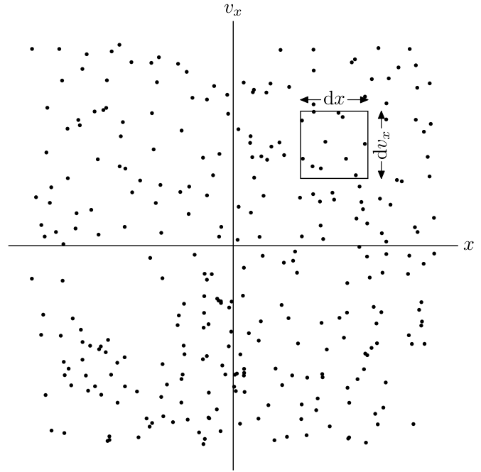
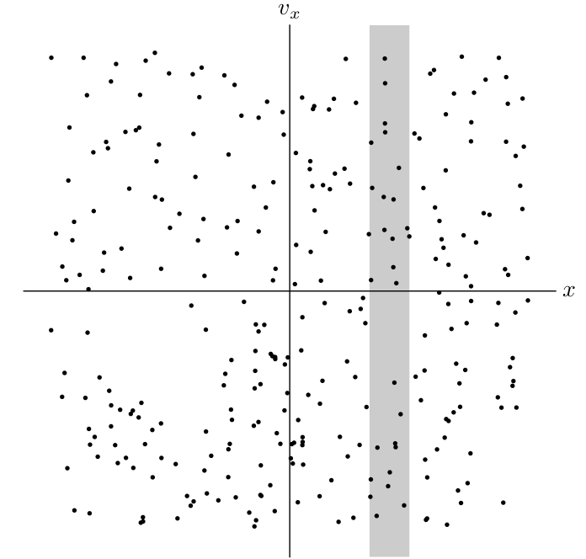
Fig. 1: Captions should be Times font, 10 pt, normal. Figures can also be embedded in the text.
Save your calendar for ESCAMPIG 2024!

At vero eos et accusamus et iusto odio dignissimos ducimus qui blanditiis praesentium voluptatum deleniti atque corrupti quos dolores et quas molestias excepturi sint occaecati cupiditate non provident, similique sunt in culpa qui officia deserunt mollitia animi, id est laborum et dolorum fuga. Et harum quidem rerum facilis est et expedita distinctio. Nam libero tempore, cum soluta nobis est eligendi optio cumque nihil impedit quo minus id quod maxime placeat facere possimus, omnis voluptas assumenda est, omnis dolor repellendus. Temporibus autem quibusdam et aut officiis debitis aut rerum necessitatibus saepe eveniet ut et voluptates repudiandae sint et molestiae non recusandae. Itaque earum rerum hic tenetur a sapiente delectus, ut aut reiciendis voluptatibus maiores alias consequatur aut perferendis doloribus asperiores repellat.
Fig. 2: Feel free to embed your images.
Sed ut perspiciatis unde omnis iste natus error sit voluptatem accusantium doloremque laudantium, totam rem aperiam, eaque ipsa quae ab illo inventore veritatis et quasi architecto beatae vitae dicta sunt explicabo. Nemo enim ipsam voluptatem quia voluptas sit aspernatur aut odit aut fugit, sed quia consequuntur magni dolores eos qui ratione voluptatem sequi nesciunt. Neque porro quisquam est, qui dolorem ipsum quia dolor sit amet, consectetur, adipisci velit, sed quia non numquam eius modi tempora incidunt ut labore et dolore magnam aliquam quaerat voluptatem. Quis autem vel eum iure reprehenderit qui in ea voluptate velit esse quam nihil molestiae consequatur, vel illum qui dolorem eum fugiat quo voluptas nulla pariatur?

Item | Format (using Times New Roman font)
Title | Bold, centered, 14 pt
Author names | Normal, centered, 12 pt
Affiliations | Italic, centered, 10 pt
Main text | Normal, justified (left and right, use hyphenation), 11pt, A4 portrait

Table 1: This table contains very important items.
At vero eos et accusamus et iusto odio dignissimos ducimus qui blanditiis praesentium voluptatum deleniti atque corrupti quos dolores et quas molestias excepturi sint occaecati cupiditate non provident, similique sunt in culpa qui officia deserunt mollitia animi. Et harum quidem rerum facilis est et expedita distinctio. Nam libero tempore, cum soluta nobis it quo minus id quod maxime placeat facere possimus, omnis voluptas assumenda est, omnis dolor repellendus.
$m\frac{d{v'}_{⊥}}{dt}=q(-\frac{(E_{⊥}×B)×B}{B^{2}}+v_{E}×B+{v'}_{⊥}×B)$, (1)
Temporibus autem quibusdam et aut officiis debitis aut rerum necessitatibus saepe eveniet ut et voluptates repudiandae sint et molestiae non recusandae. Itaque earum rerum hic tenetur a sapiente delectus, ut aut reiciendis voluptatibus maiores alias consequatur aut perferendis doloribus asperiores repellat. Sed ut perspiciatis unde omnis iste natus error sit voluptatem accusantium doloremque laudantium, totam rem aperiam, eaque ipsa quae ab illo inventore veritatis et quasi architecto beatae vitae dicta sunt explicabo. Nemo enim ipsam voluptatem quia voluptas sit aspernatur aut odit aut fugit, sed quia consequuntur magni dolores eos qui ratione voluptatem sequi nesciunt.
Place references at the end of the abstract, and cite using a numerical scheme [1].
[1] A. N. Other, J. Defined Ambiguity 22 (2018) 37–47.

